

Instructions for using the template of Revista Cátedra

Instrucciones de uso de la plantilla de la Revista Cátedra
Sergio Luján-Mora
University of Alicante, Alicante, Spain
Polytechnic School, Department of Languages and Computer Systems
sergio.lujan@ua.es https://orcid.org/0000-0001-5000-864X

Verónica Simbaña-Gallardo
Central University of Ecuador, Quito, Ecuador
Faculty of Philosophy, Letters and Education Sciences, Pedagogy of Experimental Sciences Informatics
vpsimbanag@uce.edu.ec https://orcid.org/0000-0002-7466-7364
(Received on: 20/05/2018; Accepted on: 1/06/2018; Final Version received on: 15/06/2018)

Suggested citation: Luján-Mora, S. and Simbaña-Gallardo, V. (2018). Instructions for using the template of Revista Cátedra. Revista Cátedra, 1(1), 14-34.

Abstract
In this article, the style guidelines and the instructions for using the template of Revista Cátedra are presented. These style guidelines and instructions are of obligatory use both in the preparation of the manuscript for review and in the preparation of the final version of the article for publication: an article may be rejected if it does not strictly comply with the style guidelines and instructions provided. The style of Revista Cátedra has been developed taking into account that it is an electronic journal and it will be mainly read on a screen of an electronic device, such as a computer, a tablet or a mobile phone. If you are reading a printed version of this document, you can download the corresponding Microsoft Word file from the “Instructions for Authors” web page of the journal's website to take it as a basis for writing your articles.

Keywords
Format, instructions, journal, layout, template.

Resumen
En este artículo se presentan las normas de estilo y las instrucciones de uso de la plantilla de la Revista Cátedra. Estas normas de estilo e instrucciones son de uso obligado tanto en la preparación inicial del manuscrito para su revisión como en la preparación de la versión final del artículo para su publicación: un artículo puede ser rechazado si no cumple estrictamente con las normas de estilo y las instrucciones proporcionadas. El estilo de la Revista Cátedra se ha desarrollado teniendo en cuenta que se trata de una revista electrónica que será leída principalmente en una pantalla de un dispositivo electrónico como, por ejemplo, un ordenador, una tableta o un teléfono móvil. Si está leyendo una versión impresa de este documento, puede descargar el archivo Microsoft Word respectivo desde la página “Instrucciones para los autores” del sitio web de la revista para tomarlo como base en la escritura de sus artículos.

Palabras clave
Diseño, formato, instrucciones, plantilla, revista.

Introduction
This article aims to present and explain the style and template rules that should be used when preparing an article for Revista Cátedra. This template is intended to help authors in the elaboration of their articles, but it is the responsibility of authors to ensure that the norms defined for Revista Cátedra are fulfilled at all times.
Everything explained in this article is mandatory: not complying with the style guidelines and with the template implies the non-publication of an article.
All the instructions defined in this article should be taken into account in the initial preparation of the manuscript for its review, so as to have a good estimate of the length of the article when it is finally published. In addition, the effort required to prepare the final version of the article will be minimal. Not complying with the style guidelines and with the template in the initial preparation of the manuscript ensures the immediate rejection of the manuscript without sending it to the peer review process.
This document is not a scientific article, it is an instruction manual. For this reason, some basic rules that should be applied when writing scientific articles, such as not abusing the use of bold, not writing paragraphs with a single sentence or not repeating the same word several times in the same sentence, have been violated.

Main norm
The main norm in the creation of a document is to maintain uniformity and internal coherence. In many aspects, spelling and style give freedom when it comes to writing some things, and sometimes can be discussed whether, for example, something should be written in uppercase or italic. However, once the person has chosen to write in a particular way, the person must keep writing in the same way.

General norms
The template of Revista Cátedra developed for Microsoft Word program contains the styles needed to write an article that fits the magazine's style. General style standards are:
    - No first-line indent should be defined in paragraphs, paragraphs are separated from each other because there is a posterior space of 8 pt. First-line indent often causes confusion and many authors forget to use it.
    - No blank lines should be left to separate the content from the item, blank lines hinder the correct layout of a document.
    - Underline should not be used to highlight a part of the content, the content must be put in quotation marks or bold or italics should be used, according to the usual style rules. Underline is usually used to point to errors in a document, not to highlight content.
    - Capital letters should not be used to highlight a word or text, as stated in this template neither the article title nor the titles of the sections are written in uppercase. To put the initial letter of each word in capital letters is a bad habit copied from the Anglo-Saxon style, where it is used in a generalized way.
    - Only two typefaces can be used, Calibri Light for titles and Cambria for the rest of the text. Another typeface can be used in the figures when representing an algorithm, a fragment of a code, a fragment of a text in which it is important to retain the original typeface or when it is not possible to use Calibri Light or Cambria for the limitations of the program used for creating the figure. Microsoft Word file in this template has enabled the option "Embed fonts in the file", so the fonts used in the template are available in the file. This allows other people to open the document to view and use fonts, even if they are not installed on their computers.

Norms use of roman, bold, italics, quotation marks and capital letters
The purpose of this article is to explain the template of the Revista Cátedra and the styles it has defined. This article is not intended to explain all situations that may appear during the writing of a document and may require the choice of a typeface, such as roman, bold, or italic, or the use of quotation marks or capital letters. For example:
- How should a foreign word such as “pop-rock” be written?
- How should the title of a book like "The Pilgrim Progress" be written?
- How should a company name as "Microsoft" be written?
In these situations, writing often depends on the audience, topic and scope (a means of communication, a book or a web page), on the technical means used in the writing of a document, also on the type publication of the manuscript (printed or electronic) and the style guideline of the publication in which it is written. However, there are also a number of general principles that are usually always observed. These principles can vary from one language to another, so it is not the same to write an article in Spanish, in English or Chinese.
Quotation marks to be used are:
    - Level 1: Double quotation marks "...".
    - Level 2: Single quotation marks '... '.
A short textual quotation should appear in double quotation marks; if the quoted text includes quotation marks, single quotes should be used for that text included in the quotation. For example, “opening such paragraphs with a phrase like 'as I have previously discussed' will also alert readers to the status of the upcoming material” (American Psychological Association, 2010, p. 16).
Quotation marks that are composed of an opening quotation mark (“) and a closing quotation mark (”) must be used. Do not use straight quotes "...".
To solve any doubts that may arise when writing an article in Spanish, it is recommended to consult some reference work, such as the spelling of the Spanish language (Real Academia Española y Asociación de Academias de la Lengua Española, 2010) and the Dictionary of the Spanish Language (Royal Spanish Academy and (Real Academia Española y Asociación de Academias de la Lengua Española, 2014). It is also recommended to consult the answers to specific questions that can be found on the website of the Fundéu1. For example, in this website can be found an explanation about the correct writing of titles (Fundéu, 2011b):
Titles of the works — books, films, paintings, sculptures, musical pieces, radio or television programs...— are written, as mentioned in recent spelling of the Spanish language, in italics and with an initial capital letter only in the first word and in the proper names, if the title includes one: Ulysses, War and Peace, The Great Gatsby...
When the original titles of works written in other languages are mentioned, it is advisable to apply the Spanish standard (Vanity Fair or A man for all seasons), although can be respected the writing rules of the corresponding language (Vanity Fair or A Man for All Seasons).
An explanation on the use of capital letters can be found (Fundéu, 2012b):
In fact, in a number of cases the use of capital letters is not rigid and there may be style decisions. The academic spelling establishes it on page 446, where clarifying that the use of capital letters involve «many factors, such as the intention of the person who writes, the type of text or the context of appearance».
And continues in the same page: «... it is impossible to foresee and explain all the contexts in which the writer can choose to use the capital letter or the lowercase according to very different variables, either will be considered correct».
Therefore, works such as those of Martínez de Sousa and other style experts are also valid; even though the main source is the academic text, these can be very useful complements and even essential in specialized fields (because the spelling is destined to general texts).
What is really important is to establish a single standard in a particular document to maintain uniformity and internal coherence (or even with an internal-style manual).
There is an important detail in the previous long textual quotation: the angular quotation marks "«...»”, also called Latin or Spanish, and have been preserved because they appear in the original text.
Also, an explanation about the correct writing of the foreign proper names can be found (Fundéu, 2015):
Proper names need neither italics nor quotation marks for the mere fact of being foreigners.

1 https://www.fundeu.es/

In the media, there are sometimes unnecessary quotes or italics: «The “Foreign Office” indicated that the specialists will collaborate with the Nigerian authorities», «besides live music, there is a tribute to the El Último de la Fila and another to “The Beatles”» or «the airlines “British Airways”, “Lufthansa” and “Swiss”, among the best valued by the travellers».
Although common names are written as a general rule in italics if they are not adapted to the phonological and spelling system of Spanish, the proper names, of a place, a person, a mark, an organism..., have the prominent of the capital letter; therefore, it is not necessary to add neither quotation marks nor italics.
Therefore, in the previous examples it would have been better to say «the Foreign Office indicated that the specialists will collaborate with the Nigerian authorities», «In addition to live music, there is a tribute to El Último de la Fila and another to the Beatles» and «The British Airlines Airways, Lufthansa and Swiss, among the best rated by travellers».
In addition, in the titles, either in italics or quoted, the Spanish words are not distinguished from the foreigners: «The film Minority Report is based on a story entitled El informe de la minoría».
As noted earlier, the list of situations that can be given in the writing of a document is so broad that in these rules it is not possible to offer an exhaustive relationship of all of them. For this reason, the authors are invited to consult the indicated reference works and other similar works to solve any doubts that may arise.

About copying and pasting
When copying and pasting a text that comes from another document, such as a Web page or other Microsoft Word document, it must be pasted with the “Keep Text only” option so that the source document format is not also included, as seen in the figure 1.

Sections that cannot be eliminated or modified
The following sections of the template should not be deleted or modified, and will be defined by the journal once the article is published:
    - The dates of received, acceptance and receipt of the final version in the first page.
    - The suggested citation of the article in the first page.
    - The header and footer of all pages.

Size of the paper
A journal that is published in electronic format goes to paper only when someone prints it and will almost always be made in A4 paper size (21 cm x 29.7 cm). That is why this paper size has been chosen for this template.

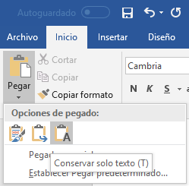
Figure 1. Option “Only keep the text” in the “paste option”

The text margins, as defined in Microsoft Word are:

- Left and right margin: 3 cm.
- Upper and lower margin: 2.5 cm.
- Header and footer: 1.25 cm from the edge.

Margins cannot be changed in any case to adjust the article to a number of pages.

Style of the article
Each meaningful part of an article has its style defined in the template: The main style, the title of the article, the authors, the summary and the keywords, the section titles, the lists and the quotations.

Main style
The main text of the article uses the “Normal” style that is defined as:
    - Source: Cambria.
    - Size:11 pt.
    - Style: normal.
    - Alignment: Justified.
    - Anterior spacing: 0 pt.
    - Rear spacing: 8 pt.
    - Spacing: single.
In any case the styles of the text, such as size or spacing, can be changed to adjust the item to a number of pages.

Title of the article
The title of the article uses the “title” style, which is available in the list of styles as shown in Figure 2.

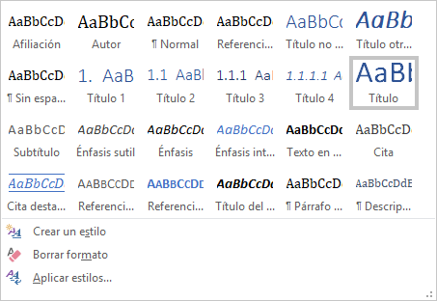
Figure 2. “Title” style selected from the list of styles

The “title” style is defined as:
    - Source: Calibri Light.
    - Size: 28 pt.
    - Style: Bold.
    - Alignment: centered.
    - Anterior and posterior spacing: 24 pt.
    - Spacing: single.
    - Color: RGB (47, 84, 150).

The style of the title cannot be modified to highlight a part with bold, italic or any other format.

A final point is not used at the end of the title.

The title of the article should not be written in uppercase. The first letter of the words that do not normally require should not be capitalized. For example, “Instructions for the template use of Revista Cátedra” and not “Instructions For The Template Use Of Revista Cátedra” or “INSTRUCTIONS FOR THE TEMPLATE USE OF REVISTA CÁTEDRA”.

Title in another language
The title of the article in another language uses the “Title in another language” style that is defined as:
    - Source: Calibri Light.
    - Size: 20 pt.
    - Style: bold and italic.
    - Alignment: centered.
    - Anterior and posterior spacing: 24 pt.
    - Spacing: single.
    - Color: RGB (47, 84, 150).
To write the title of the article in another language, follow the additional style rules defined in section 3.2.

Authors
The author's name uses the “author” style that is defined as:
    - Source: Cambria.
    - Size: 14 pt.
    - Style: normal.
    - Alignment: Right.
    - Anterior spacing: 6 pt.
    - Rear spacing: 3 pt.
    - Spacing: single.
The affiliation of the author uses the style “affiliation” which is defined as:
    - Source: Cambria.
    - Size: 11 pt.
    - Style: normal.
    - Alignment: right.
    - Anterior and posterior spacing: 0 pt.
    - Spacing: single.
The author's e-mail and Open Researcher and Contributor ID2 (ORCID) use the “affiliation” style for the paragraph and the “hyperlink” style for the text. the "hyperlink" style is defined as:
    - Font: the same as the source font of the related text.
    - Size: the same as the default size of the related text.
    - Style: underlined.
    - Color: RGB (5, 99, 193).

Abstract and keywords
The titles of “abstract” and “keywords”, use the “Unnumbered title” style that is defined as:
    - Source: Calibri Light.
    - Size: 16 pt.
    - Style: normal.
    - Alignment: left.
    - Anterior spacing: 12 pt.
    - Rear spacing: 0 pt.
    - Spacing: single.
    - Color: RGB (47, 84, 150).
A final point is not used at the end of titles.
The text of the sections “abstract” and “keywords” uses the “Normal” style. The abstract written in English must use British or American English, selected in Microsoft Word.

Title of sections
Titles of sections use the styles “Title 1”, “Title 2” and “Title 3”, which are generally defined as:

2 https://orcid.org/

    - Source: Calibri Light.
    - Style: normal.
    - Alignment: justified.
    - Spacing: single.
    - Color: RGB (47, 84, 150).
And particularly:
    - Title 1:
- Size: 16 pt.
- Previous spacing: 12 pt.
- Posterior spacing: 0 pt.
    - Title 2:
- Size: 13 pt.
- Previous spacing: 2 pt.
- Posterior spacing: 0 pt.
    - Title 3:
- Size: 12 pt.
- Previous spacing: 2 pt.
- Posterior spacing: 0 pt.

The style of a section’s title cannot be modified to highlight a part with bold, italic, or any other format.

A final point is not used at the end of a section's title.

The title of a section should not be written in uppercase. The first letter of the words that do not normally require it should not be capitalized. For example, must be written “section titles” and not “Section Titles” or “SECTION TITLES”.
A depth level of more than three sub-divisions should not be used because it hinders the reading and understanding of the article. Section titles are numbered according to their depth level as follows:
- Title 1:1. Title
- Title 2:1.1 Title
- Title 3:1.1.1 Title
Section titles are numbered for an easy reference in other parts of the document. A point is not used at the end of the title.
Titles of “Acknowledgements”, “References” and “Authors” sections use the “unnumbered title” style defined in section 3.5.
The correct use of styles for section titles can be checked in the “Browsing” panel, “Titles” option, as shown in Figure 3.

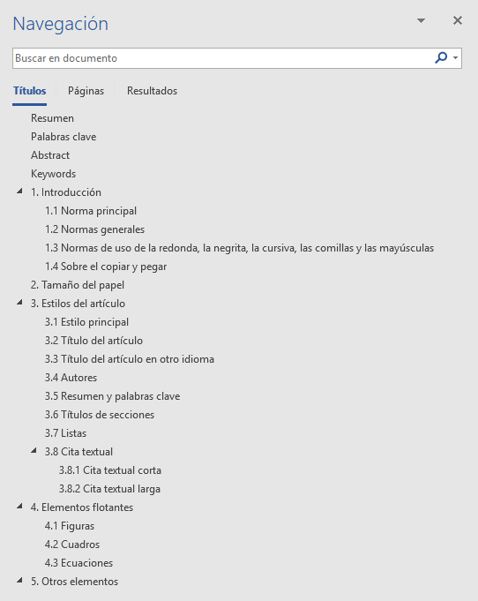

Figure 3. “Browse” panel with the section titles of a document

Lists
Lists help to highlight the main details of a text, while making it more visually attractive, but should be used with moderation; if an article has a lot of lists, these will lose their effectiveness. Therefore, lists should not be used to emphasize unimportant things.
Numbered lists must follow the following sequence according to the depth level:
- Level 1: An Arabic number with a point, starting from “1”.
  - Level 2: A lowercase letter with a point, starting from “a”.
    - Level 3: A roman number with a point, starting from “I”.
Unnumbered lists, also called bullet lists, must follow the following sequence according to the depth level:
    - Level 1: A fill square.
- Level 2: a filled circle.
  - Level 3: an empty circle.
Highlighted lists can be used, both numbered and unnumbered. In a highlighted list, each item in the list is highlighted in bold and the following paragraph (s) includes the element's explanation. For example, some typical errors in writing scientific articles are corrected:
    - The prefix is written together with the accompanying word. According to Fundéu (2011a), “Prefixes are written together with the accompanying word (antivirus, supermodel, exhusband, vicepresident, overfeeding, counteroffer, precandidate); Therefore, the spelling in which the prefix appears united with a script (vice-minister, anti-mafia) or separated by a blank space (vice minister, anti mafia)” is not appropriate. However, there are some exceptions: “The prefix will be written with hyphen when the next word starts with a capital letter or a number”; “the prefix will be separated only if it affects several words that behave like a unit”; and, “if several prefixes are put before several words that behave as a unit, they will be separated from each other and from the group of words to which they modify”.
    - “And/or” combination is an unnecessary formula. According to Fundéu (2011c), “the formula and/or which is a calque of the English and/or, is almost always unnecessary because the conjunction or is not exclusive; therefore, as indicated by the Pan-Hispanic Dictionary of Doubts, its use is discouraged, «unless it is essential to avoid ambiguities in very technical contexts»”.
    - % is written separately from the number it accompanies. According to Fundéu (2012A), “When written a number followed by a symbol, such as the percentage (%), it is advisable to leave a space among them”.
Each item in a list, even a single word, must start with an initial capital letter and end with a point.
A depth level higher than three sub-divisions cannot be used in the lists because it makes it difficult to read and understand the article.
It is not recommended to use online lists (in the text), but if necessary the following style must be used: 1) first element; 2) second element; 3) third element.

Textual quotation
A textual quotation is a literal copy of a fragment of another author's work. To prevent plagiarism from being considered, the author and the origin of the fragment must be correctly identified: in addition to indicating the work of the other author, the page number in which the copied fragment is found must be indicated. If the work is not organized in pages, such as in the case of a web page, try to indicate the number of paragraph in which the copied text is located.
As explained in section 1.4, when copying and pasting a text that comes from another document, such as a web page or other Microsoft Word document, pasting must be done with the "Preserve text only" option so that the source document format is not included. However, in the case of a textual quotation the highlight of the original text must be kept, such as bold or italic.
Two types of quotations are distinguished, the short textual quotation and the long textual quotation. There is also paraphrase, although it does not use a special style to highlight it.

Short textual quotation
A short textual quotation is one that has less than 40 words and is not a single full paragraph (i.e. if the textual quotation has less than 40 words, but is a full paragraph, should be treated as a long textual quotation). The limit of less than 40 words is taken from the American Psychological Association (2010, p. 170).
A short textual quotation should appear in double quotes; if the quoted text includes quotation marks, single quotes must be used for that text included in the quotation. The source should be indicated at the beginning or end of the short textual quotation.
For example, the following is a fragment containing the single quotes because the original document uses double quotes to highlight a few words: “Opening such paragraphs with a phrase like 'as I have previously discussed' will also alert readers to the status of the upcoming material” (American Psychological Association, 2010, p. 16).
Quotation marks that are composed of an opening quotation mark (“) and a closing quotation mark (”) must be used. Straight quotes "..." are not allowed.
Since a short textual quotation already has the highlight of the quotation marks, it is not necessary to add another highlight like italic.
A short textual quotation should not be written in an independent paragraph, because that is the purpose of the long textual quotation.

Long textual quotation
When the extension of a textual quotation is 40 or more words or consists of one or more paragraphs, a long textual quotation must be used, and it does not use quotation marks. The long textual quotation must be written in one or more separate paragraphs. The source of the text must be indicated before the long textual quotation or at the end.
The style used is “Quotation” which is defined as:
    - Source: Cambria.
    - Style: normal.
    - Alignment: justified.
    - Spacing: single.
    - Anterior spacing: 10 pt.
    - Rear spacing: 8 pt.
    - Left and right indent: 1.52 cm.
    - Color: RGB (64, 64, 64).
This is an example of a long textual quotation:
If the quotation comprises 40 or more words, display it in a freestanding block of text and omit the quotation marks. Start such a block quotation on a new line […] At the end of a block quotation, cite the quoted source and the page or paragraph number in parentheses after the final punctuation mark. (American Psychological Association, 2010, pág. 171)

Paraphrase
Paraphrase is the “amplifying explanation or interpretation of a text to illustrate it or make it clearer or intelligible” (Real Academia Española and Asociación de Academias de la Lengua Española, 2014). A paraphrase should cite the original source on which the interpretation is based on. If referring to a full text, it is not necessary to indicate the number of pages, because they would be the same pages that appear in the bibliographical reference; however, if referring to a specific part of the text, it is necessary to indicate the specific pages, as if it were a textual quotation.

Floating elements
In some editing programs, floating elements are those that can vary their position in a document depending on the text around them. Normally, the floating elements are the figures, the tables and the equations.
Figures and tables must have a short but descriptive and explanatory title of the content. The title can occupy several lines of text, but it is advisable not to exceed three lines. Equations are only numbered.
Due to the limitations that Microsoft Word presents in the handling of floating elements, these must be inserted in the text. Figure 4 shows the “Design options” that appear in Microsoft Word when an image is inserted, the “in-line with the text” option must be selected.
The floating elements should be centered on the width of the page so that there are no exaggerated vertical blanks on the pages.
The floating elements should be quoted correctly, as if they were text:
- If the floating element is created by the author, no indication should be included.
- If the floating element is taken directly from another work without any modification, at the end of the title must be added “Source:” and the corresponding reference, including the page. For example, Figure 5 has been copied directly from the book Writing Science by Schimel (2012).
- If the floating element is taken directly from another document but has been modified or has been redrafted from scratch (for example, it has been improved or translated), at the end of the item's title must be added “adapted from:” and the bibliographic reference including the page number. For example, Figure 6 is the same as shown in Figure 5, but it has been translated from English to Spanish, so it is indicated “Adapted from:” Instead of “Source:”.
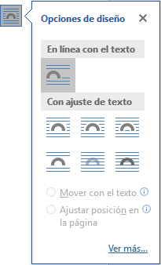
Figure 4. Content menu “Design options” of a figure

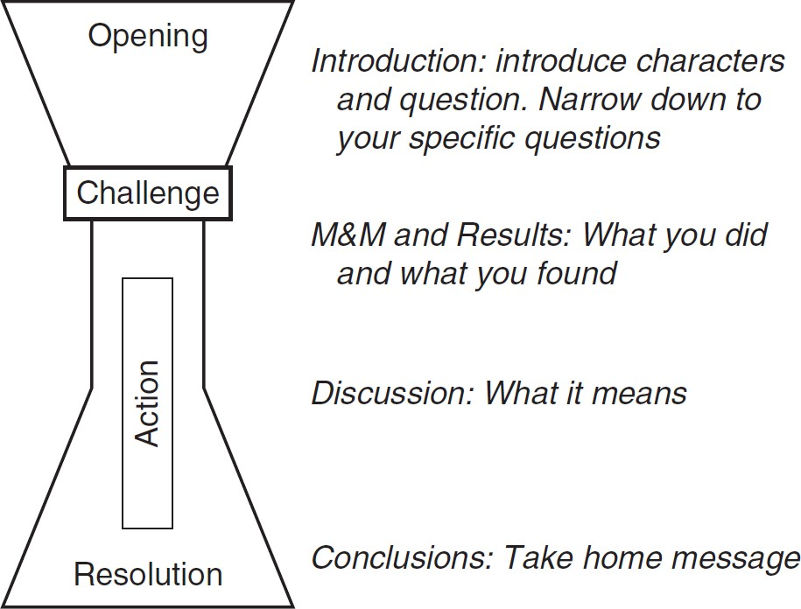

Figure 5. The structure of an article. It begins with a wide opening, then narrows with the challenge and action, and is widened again in the resolution. Source: (Schimel, 2012, p. 33).

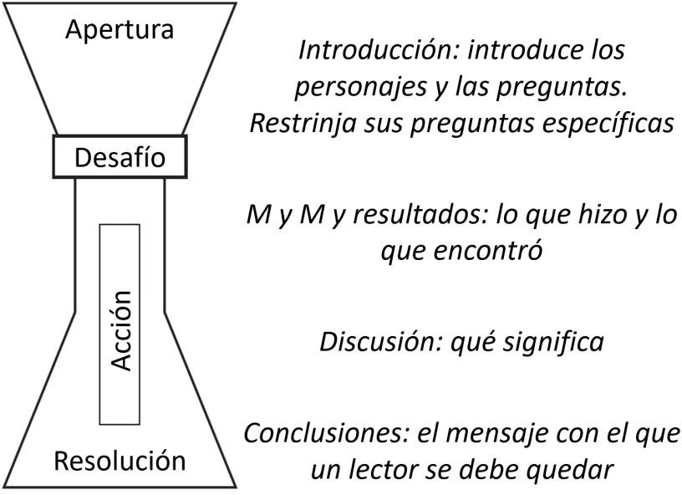
Figura 2. La estructura del reloj de arena de un artículo. Comienza con una apertura amplia, se estrecha con el desafío y la acción, y se ensancha de nuevo en la resolución. Adaptado de: (Schimel, 2012, pág. 33).

Figures
A figure can be a photograph, a drawing, an illustration, a graph, an algorithm, a part of a code, etc. A table (see section 4.2) should not be treated as if it was a figure, and a table cannot be inserted directly into the document as an image.
Figures should be mentioned and referenced in the text at least once, and before they appear in the text. The first explanation of a figure should provide a summary of its content and an explanation of its organization. The interpretation of the figure should appear just after this; however, if this causes a negative result, such as the wrong position of the figure or that there is an excessive spacing; the interpretation can be placed just after the figure.
Figures should be placed at the top or bottom of a page, never in the middle of the page, with information before and after the figure. For example, in Figure 7, two possible pages of a document created with the template of this journal are shown in parallel. In the page on the left, the figure is incorrectly positioned because it appears in the middle of the page, with text before and after; on the right page, the figure is correctly positioned because it appears at the bottom of the page and there is only text before the figure.
The width of a figure should not exceed the limits set for the text, that is, a figure should never invade the margins of the page. A figure should not be larger than a page and should not be placed between two pages.
The font of a figure should be either Calibri Light or Cambria. Except where it is not really necessary to read the text containing a figure (for example, when it is a screenshot in which the important thing is the general distribution of the contents on the screen and not the specific detail), the size of the text must be large enough so that it can be read without difficulty.
The title of a figure should be located below the figure and on the same page, never on the next page. The title of a figure uses the “description” style that is defined as:
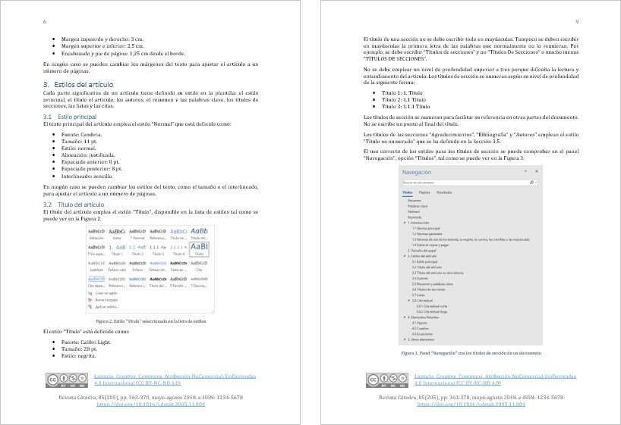
Figure 7. Example of a positioning of figures in a page

    - Source: Cambria.
    - Size: 9 pt.
    - Style: normal.
    - Alignment: centered.
    - Anterior spacing: 6 pt.
    - Rear spacing: 10 pt.
    - Spacing: single.
    - Color: RGB(68, 84, 106).
The title of the figure serves as identification and explanation of this, therefore the figure should not include a title on it.
The quality of figures must be excellent. The “Do not compress file images” option is selected in the Microsoft Word options in this template, as shown in Figure 8. This option should not be modified.
It is recommended to work with images with the maximum resolution possible and in PNG or TIFF format. The JPG or JPEG formats, which are very common nowadays, are formats that achieve high compression levels, but at the cost of reducing the quality of the images.
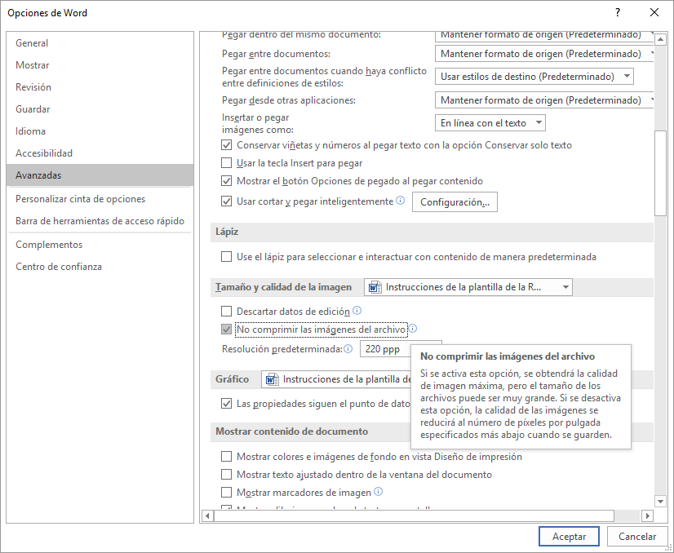
Figure 8. “Do not compress file images” option selected in “Options of word”

To include a reference to a figure in the text, use the “cross-reference” feature available in the "References" menu. If when editing the expected numbering is not displayed in a cross-reference, all fields can be updated in a document by selecting the entire document (typically Ctrl + E) and pressing F9, as explained in updating fields3.

Tables
In the Anglo-Saxon publishing culture, the term table is used to refer to the two-dimensional representation, organized in rows and columns of a data set. In Spanish the use of the term table is used as a calque of English, but the tradition recommends the use of the term picture. Therefore, in this journal is used the term picture, which in Diccionario de la lengua española4 de la Real Academia Española (2014) appears with the following meaning:
9. m. A set of names, figures or other data presented graphically, in such a way as to warn the relationship between them.
Tables should be mentioned and referenced in the text at least once and before the table appears. A summary of the contents of the table and an explanation of its organization and interpretation should be provided. For example, table 1 is included in this article to show how a table is referenced.
Tables should be placed at the top or bottom of a page, never in the middle of the page with text before and after the figure. The width of a text should not exceed the limits set for the text, that is, a box should never invade the margins of the page. A box should not be larger than a page and should not be placed between two pages.
The font of a table must be Cambria, like in the rest of the article. The design of a table should only use horizontal division lines; vertical lines should be avoided.
The title of a table should be placed under the table and on the same page, never on the next page. The title of a table uses the "description" style and is centered.
The title of a table serves as identification and explanation of this, therefore the table should not include a title on it.

Equations
Microsoft Word Equation Editor must be used to create the equations. Inserting equations as images should be avoided.
Equations should be mentioned and referenced in the text at least once and before the equation appears.

Header of the colum | Header of the colum | Header of the colum | Header of the colum | Header of the colum
Header of the line | 123 | 123 | 123 | 123
Header of the line | 56 | 11456 | 456 | 456
Header of the line | 1789 | 33 | 789 | 789
Header of the line | 123 | 1234 | 123 | 123
Header of the line | 44 | 456 | 456 | 456
Header of the line | 789 | 789 | 789 | 789
Table. Example of a table

Equations should be centered and identified with the title “Equation n”, as observed in Equation 1.

𝑥 =
−𝑏 ± √𝑏² − 4𝑎𝑐

2𝑎
Equation 1

The title of an equation should be placed under the table and on the same page, never on the next page. The title of an equation uses the “description” style and is centered. The symbols of an equation must be defined before they appear in the equation or immediately thereafter.

3 https://goo.gl/fW66cE
4 “Titles of works —books, films, paintings, sculptures, musical pieces, radio or television programs...— are written, as the recent spelling of the Spanish language states, in italics and with an initial capital letter only in the first word and in the proper names" (Fundéu, 2011b

References
It is recommended to use a bibliographic manager, such as Mendeley or Zotero, to create the bibliography of an article. Otherwise, the Bibliographic manager that incorporates Microsoft Word is another option. It is not recommended to create bibliography and quotations manually because of the errors that are usually produced.
Figure 9 shows the Microsoft Word “font manager” main window, which is available through the "References" menu. Through this window can be selected fonts for the current document and new fonts can be created.
Microsoft Word's bibliographic manager has some limitations that must be solved manually. For example, when two or more articles are quoted from the same authors and in the same year, Microsoft Word does not automatically number the year as “2018, 2018b, 2018c,...”, and it should be corrected manually.

Other elements

Header and footnotes
The authors of an article should not modify the header and footnotes defined in this template. Its contents will be established by the technical team of the Revista Cátedra in the final version of the article.

Footnotes
Footnotes are allowed but its use should be limited as they hinder the reading a document. Footnotes should indicate additional information that is not essential for understanding the main text.

Cross references
If referring to a section, a figure, a table, or an equation, the “cross-reference” option available in the “References” menu should be used. The name of the reference element must be typed in uppercase. For example, Figure 10 shows the “Cross-reference” window of Microsoft word and the word “figure” has been written in uppercase by being a reference.

Links
Links, which are also call hyperlinks, must use the “Hyperlink” style.

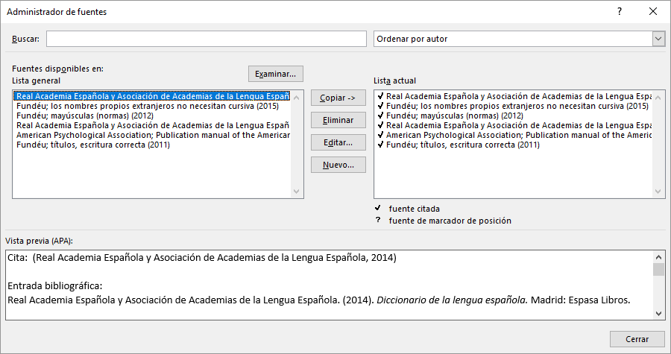
Figure 9. Main window of “Source administrator” “of the “References” menu

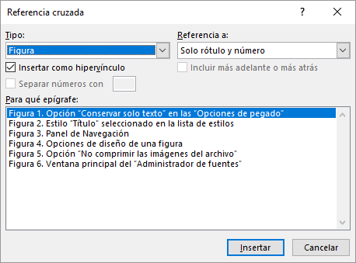
Figure 10. Insertion of a cross reference

Acknowledgment
This section is optional.

Bibliographic references
American Psychological Association. (2010). Publication manual of the American Psychological Association (6 ed.). Washington, DC: American Psychological Association.
Fundéu. (2011a). prefijos: cuatro claves para una buena redacción. Recuperado el 25 de junio de 2018, de https://www.fundeu.es/recomendacion/prefijos-cuatro-claves-para- una-buena-redaccion-817/
Fundéu. (2011b). títulos, escritura correcta. Recuperado el 25 de junio de 2018, de https://www.fundeu.es/recomendacion/titulos-escritura-correcta/
Fundéu. (2011c). y/o, fórmula innecesaria. Recuperado el 25 de junio de 2018, de https://www.fundeu.es/recomendacion/yo-formula-innecesaria-1021/
Fundéu. (2012a). el % se escribe separado de la cifra a la que acompaña. Recuperado el 25 de junio de 2018, de https://www.fundeu.es/recomendacion/el-se-escribe- separado-de-la-cifra-a-la-que-acompana-802/
Fundéu. (2012b). mayúsculas (normas). Recuperado el 25 de junio de 2018, de https://www.fundeu.es/consulta/normas-sobre-uso-de-mayusculas-27610/
Fundéu. (2015). los nombres propios extranjeros no necesitan cursiva. Recuperado el 25 de junio de 2018, de https://www.fundeu.es/recomendacion/nombres-propios- extranjeros-cursiva/
Real Academia Española y Asociación de Academias de la Lengua Española. (2010).
Ortografía de la lengua española. Madrid: Espasa Libros.
Real Academia Española y Asociación de Academias de la Lengua Española. (2014).
Diccionario de la lengua española. Madrid: Espasa Libros.
Schimel, J. (2012). Writing science : how to write papers that get cited and proposals that get funded. New York: Oxford University Press.

Authors
SERGIO LUJÁN-MORA obtained his PhD degree in computer engineering from the Department of Languages and Computer Systems of the Universidad de Alicante (Spain) in 2005. He obtained the degree of computer engineer at Universidad de Alicante in 1998 and the title of technical engineer in computer systems at Universidad de Alicante in 1997.
He is currently a tenured professor in the Department of Computer Systems at Universidad de Alicante. He is editor in chief of Revista Cátedra of the Faculty of Philosophy, Letters and Education Sciences of Universidad Central del Ecuador. He is chairman of the program Committee of the International Conference on Information Systems and Computer Science (Inciscos) organized by Universidad Tecnológica Equinoccial (Ecuador). His main research topics include Web applications, Web development, web accessibility and web usability. In recent years, he has focused on online learning (e-learning), massive open online courses (MOOC), open educational resources (OER), and accessible video games. He is the author of several books and numerous articles published in several conferences (ER, UML, DOLAP) and magazines of Alto
VERÓNICA SIMBAÑA-GALLARDO obtained her master's degree in Latin American and Ecuadorian literature from the Faculty of Communication, Linguistics and Literature of Pontificia Universidad Católica del Ecuador (Ecuador) in 2015. She obtained a master's degree in Higher Education and Gender Equity from the Faculty of Philosophy, Letters of Education Sciences of Universidad Central del Ecuador (Ecuador) in 2007. She obtained the title of specialist in design and management of educational and social projects with a gender focus by the Faculty of Philosophy, Letters and education Sciences at Universidad Central del Ecuador in 2007. She obtained a degree in Education Sciences, professor of secondary education in the specialization of language sciences and literature by the Faculty of Philosophy, Letters and education Sciences of Universidad Central del Ecuador in 2002.
She is currently a professor of the Faculty of Philosophy, Letters and Education Sciences at Universidad Central Ecuador. She is columnist and member of the International Council of Reviewers of Sophia journal Universidad Politécnica Salesiana (Ecuador). She is editor in chief of Revista Cátedra of the Faculty of Philosophy, Letters and Education Sciences at Universidad Central del Ecuador. Her main research topics include the didactics of literature, the development of metacognitive strategy to improve the level of reading comprehension, strategies of literary analysis through the study of descriptive textual methods such as formalism, structuralism, stylistic and hermeneutics. She is the author of chapters of books and articles published in high-impact journals (Emerging Source Citation Index, Latindex, Redalcy, Scielo).

Statement of Authorship-CRediT
SERGIO LUJÁN-MORA: state of the art, related concepts, methodology, validation, data analysis, writing- first draft.
VERÓNICA SIMBAÑA-GALLARDO: state of the art, related concepts, data analysis, organization and integration of collected data, conclusions, final drafting and editing.

